**IMPORTANT INFO REGARDING DIRECTIONS & LOADING YOUR WORK INTO THE SHOW**

1. Follow directions to the Merchandise Mart Loading Dock  
    ***From Northwest:*** Take I-90/94 East (Kennedy) to downtown Chicago. Exit at Ohio Street. Continue east on Ohio until you reach Wells Street. Take a right on Wells. Continue for four blocks. Turn right onto Kinzie Street and pass 2 STOP signs before turning left under the viaduct into the Merchandise Mart Loading Dock.

***From Lake Shore Drive:*** Take Lake Shore Drive and exit at Upper Wacker Drive. Continue west on Wacker until you reach Orleans Street. Turn right and cross the bridge. Continue to Hubbard Street and turn right and then another quick right onto Orleans Street. After STOP sign, veer right/straight to enter the Merchandise Mart Loading Dock.  
  
***From West:*** Take I-290 East (Eisenhower) and merge onto I-90W/I-94W toward Wisconsin. Take the Lake Street Exit 51A and then turn right onto W. Lake Street. Take the first left onto N. Desplaines Street. Turn right onto W. Kinzie Street and head East over the bridge. After the bridge, pass the STOP sign at Kingsbury Street and under the viaduct turn right to enter the Merchandise Mart Loading Dock.

***From Southwest:*** From I-55 North (Stevenson) merge onto I-90W/I-94W. Take the Lake Street Exit 51A and then turn right onto W. Lake Street. Take the first left onto N. Des Plaines Street. Turn right onto W. Kinzie Street and head East over the bridge. After the bridge, pass the STOP sign at Kingsbury Street and under the viaduct turn right to enter the Merchandise Mart Loading Dock.

1. 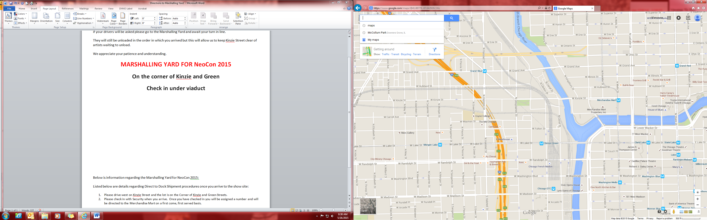Once you arrive at the loading dock you will be instructed to either pull in (if there is space) or go to the staging area across the street at Wolf Point.

**Loading Dock**